**Lab 1**

**Submitted by:**

**Ankit Kumar**

**Student ID: 22022985**

**Submitted to:**

**Professor: Nawaz Chowdhury**

**Subject: Computer environment and tooling**

**Course code: CSD213**

Honesty Statement: “I declare that this submission is my own work in compliance with Sault College Academic Policies.”

**Due date: 24 January 2024**

# **Table of Contents**

**Table of Contents** 3

Table of Figures 3

# Table of Figures

Figure 1: Code for Add Row Button 5

Figure 2: Result of Figure 1 5

Figure 3: Code for Delete row button. 6

Figure 4: Delete Row Button Pressed Once. 6

Figure 5: Delete row Button Pressed again. 6

Figure 6: Validation code Added. 7

Figure 7: Validation Code Result. 7

Figure 8: Validation Code For Removing the Validation 8

Figure 9: Figure 8 Code Executed. 8

Figure 10: code for new Button 9

Figure 11: Code for Delete from bottom function. 9

Figure 12: Before button pressed 9

Figure 13: After Button Pressed 9

Figure 14: Styles Code 10

Figure 15: Styles Executed 10

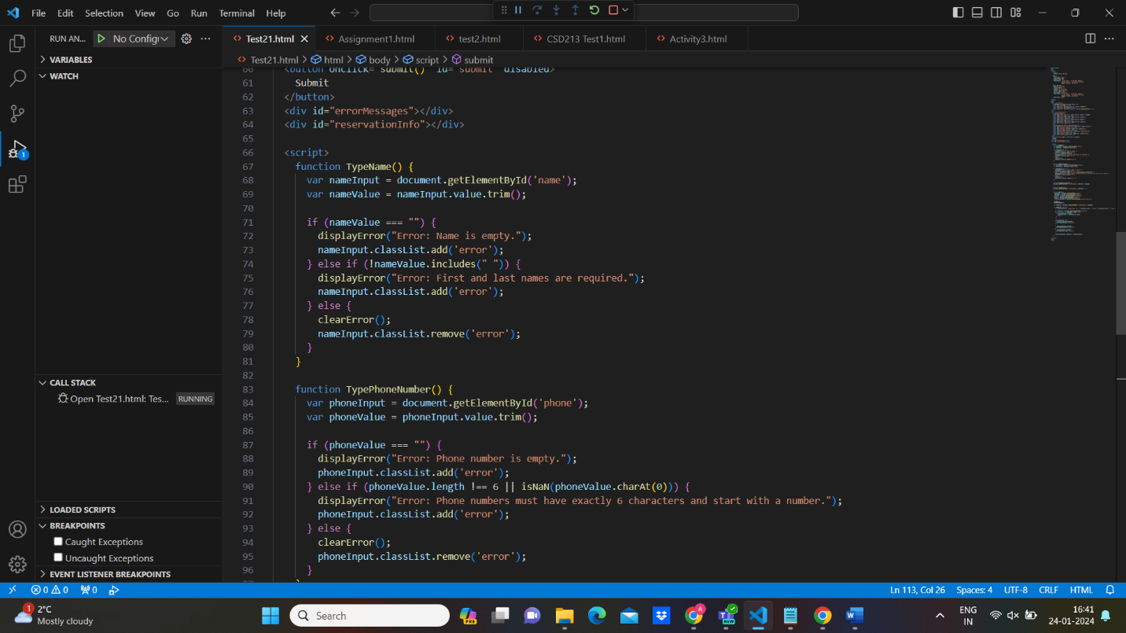**Fig 1. Code for Type name A screenshot of a computer

Description automatically generatedResults when Name Is empty**

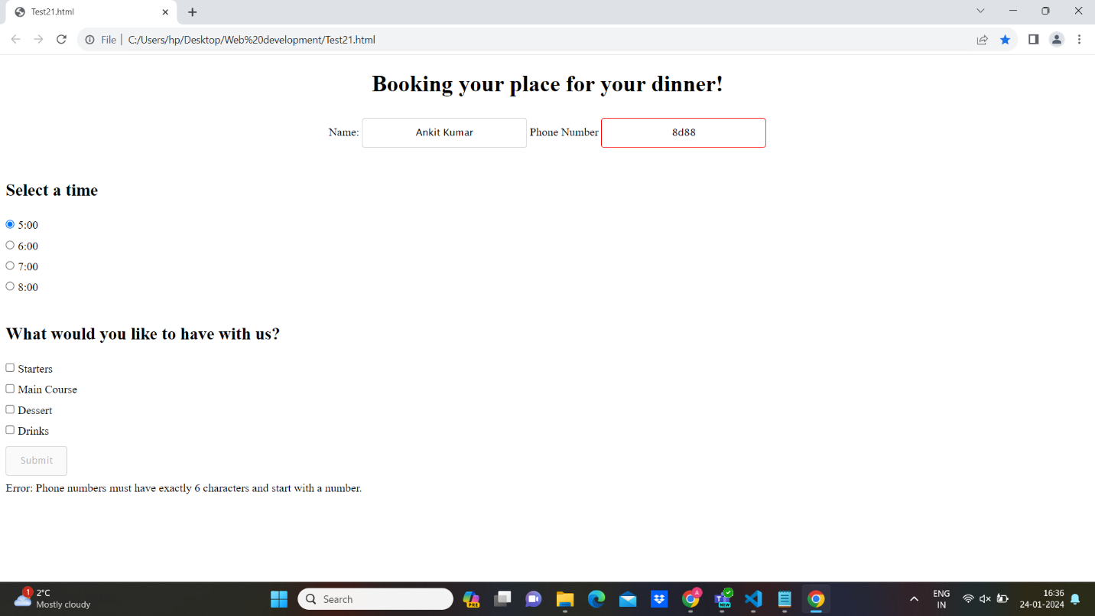**fig 3.. Phone number should have exact 6 characters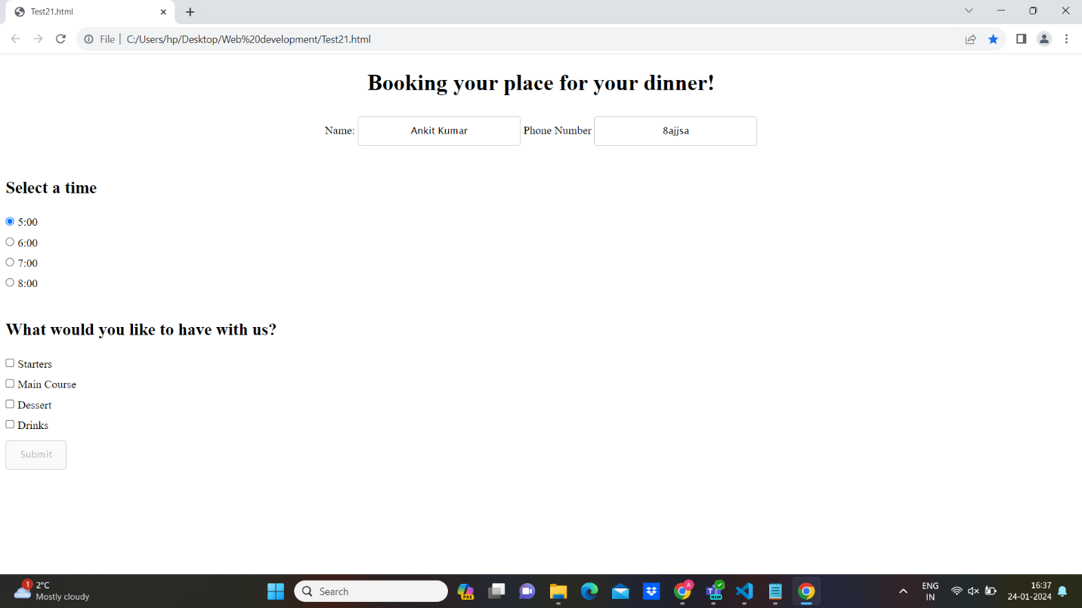fig4.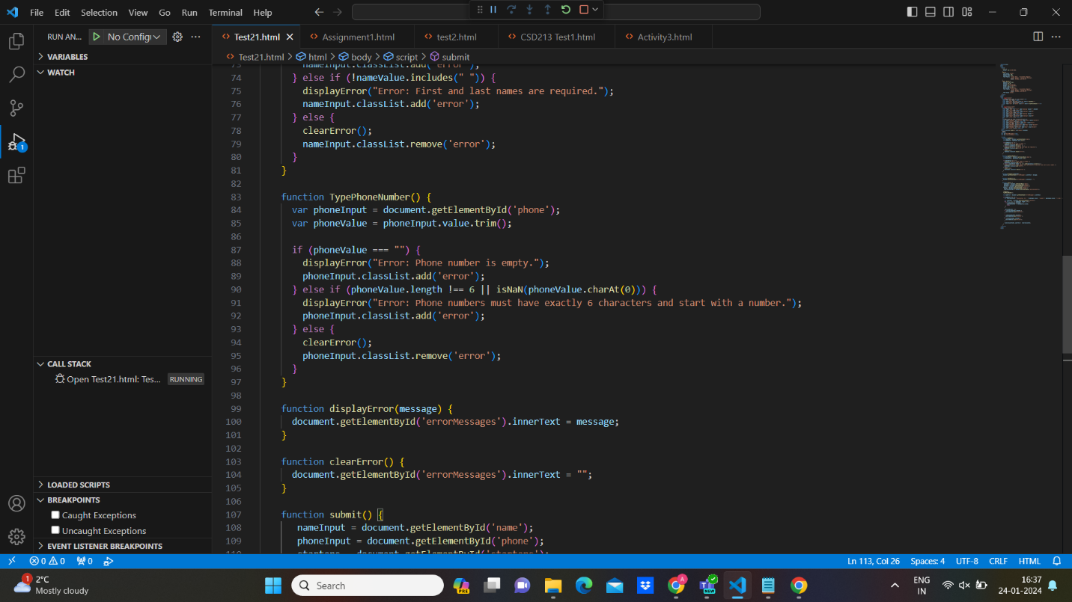code for Typenumber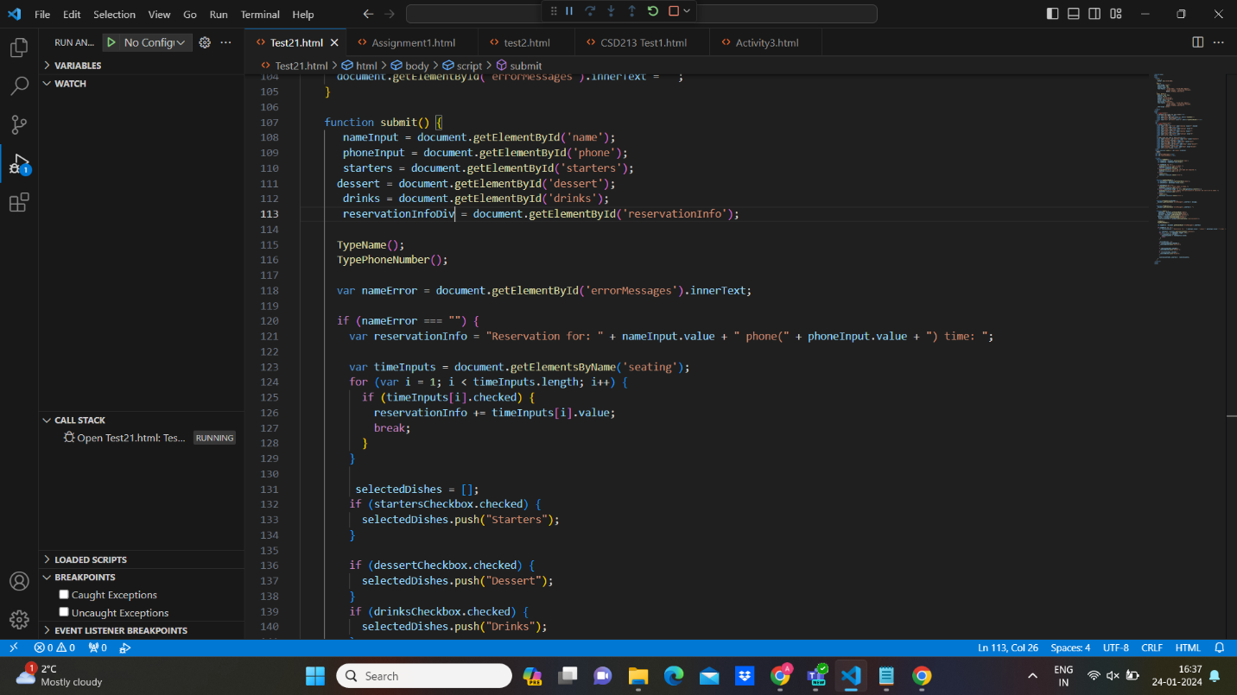code of Reservation for the customer** 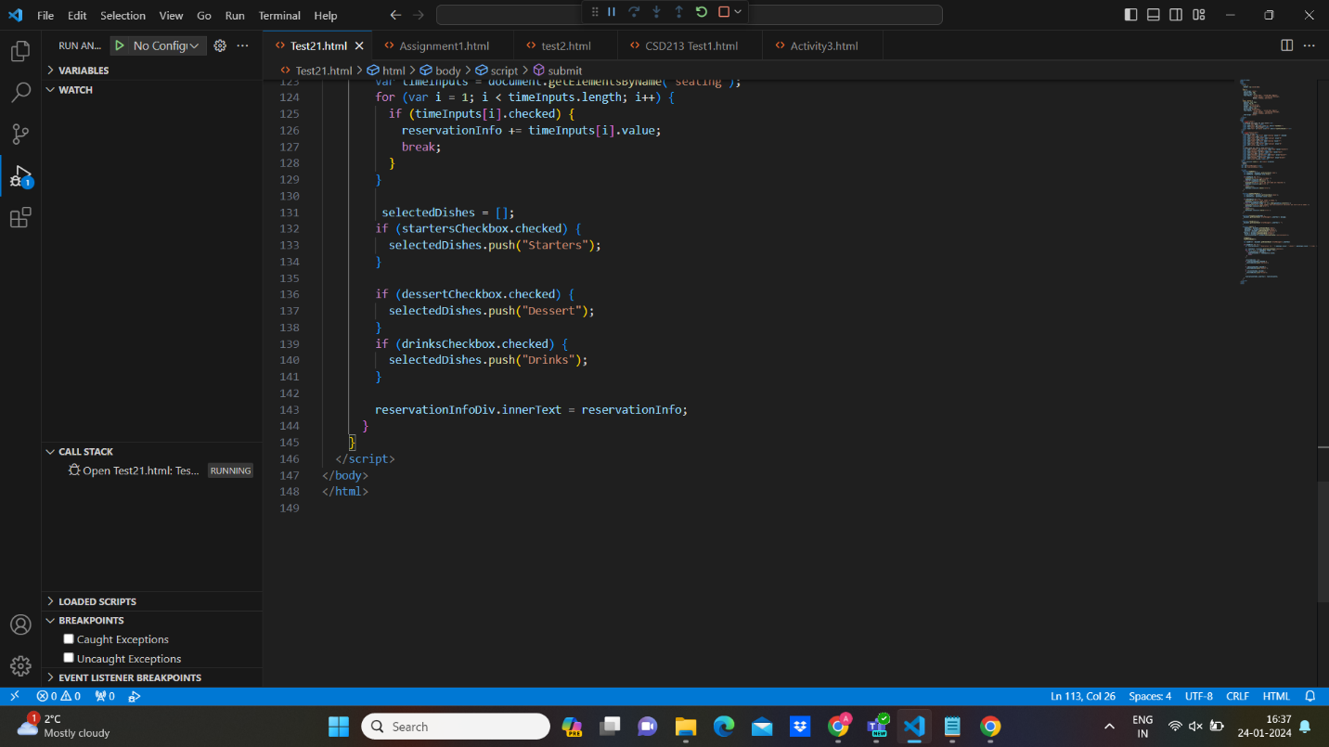

**References:** *Java Delete Files*. (n.d.). Www.w3schools.com. https://www.w3schools.com/java/java_files_delete.asp